

KINO LORBER ACQUIRES ALL NORTH AMERICAN RIGHTS TO RADIO UNNAMEABLE, A DOC ABOUT LEGENDARY RADIO HOST BOB FASS.

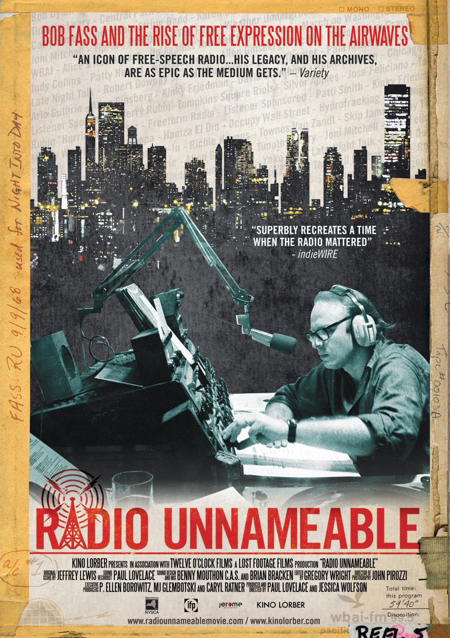
New York Premiere Set for September 19 at Film Forum

New York, NY – August 30, 2012 - Kino Lorber, Inc. is proud to announce the acquisition of all North American rights to RADIO UNNAMEABLE, a documentary about Bob Fass, the legendary radio personality who revolutionized late night, free-form radio programming and gave new meaning to the very idea of independent media.

His show Radio Unnameable, which first aired in 1963 on WBAI (a New York radio station) and still gets broadcast every Thursday night (from 12 to 3am), became a cultural hub for music, politics and audience participation; his guests included the likes of Arlo Guthrie, Allen Ginsberg, Kinky Friedman, Abbie Hoffman, Bob Dylan and Carly Simon – many of whom are seen in this documentary.

Long before today’s innovations in social media, Fass utilized the airwaves for mobilization, encouraging luminaries and ordinary listeners to talk openly and take the program in surprising directions.

Set to have its North American theatrical premiere on September 19, at New York’s Film Forum, RADIO UNNAMEABLE will expand to other cities in the U.S. and Canada during the following months.

Directed by Paul Lovelace (The Holy Modal Rounders... Bound to Lose) and Jessica Wolfson, RADIO UNNAMEABLE is a visual and aural collage that draws extensively from Bob Fass's immense archive of audio, film, photographs, and video that has been sitting dormant until now.

The film traces Fass’ participation in many pivotal moments in the history of New York City and the U.S. overall, including the anti-war protests of the 1960s and 70s, showcasing how his work ethic, passion for the medium, and creativity helped create the very notion of citizen journalism.

From midnight to 5 a.m., five nights a week, Bob Fass’ soothing voice was heard over the airwaves on WBAI-FM. He became famous for letting the talk and music flow all night long, as some of the city slept and some of it followed him to a “Yip-In” at Grand Central Station, to demonstrations at the1968 Chicago Democratic Convention, and a “human fly-in” at JFK airport, just a few cases of his culturally transformative radio rallying.

Kino Lorber's CEO Richard Lorber, who negotiated the deal with attorney George Rush, representing the filmmakers, commented: “New York-based Bob Fass has been a defining figure and inspiring visionary on the national media scene for half a century. We are thrilled to introduce Paul and Jessica’s Radio Unnameable to a new media generation – they’ll get the potent changes he wrought. His prophetic radio savvy and passionate political conscience transformed our culture. The almighty Internet today seems just an echo of what he was able to do alone, every night, live on air.”

